AN ESSAY TO SHARE

Modern Science Confirms Ancient Teachings
The Alignment of Quantum Physics with Yoga Philosophy
An essay you can share or copy from and make your own
by Shelly Thorn
v 2.0

Table of Contents
Science & Spirituality Converge 3
When We Free Ourselves from Mainstream Shackles, Wonders Abound 4
What the Bleep Do We Know? 4
Everything Emerges Out of Cosmic Potentiality 6
Step-by-Step, In All Ways, The Possibilities Are Endless 7
Mainstream Science Has Been Wrong for a Long Time 8
When Things Don’t Add Up, Check the Assumptions & Question the Models 12
Our World is Much More Exciting Than We’ve Been Led to Believe 14
The Mandela Effect 14
Paying Attention Allows Us to See the (Sometimes Shocking) Magic 16
What Does It All Mean and Why Should We Care? 17
The Field Brings It All Together 17

Science & Spirituality Converge
One of the oldest and most profound truths is the Vedic teaching that Atman (the divine spirit or awareness within us) equals — is one with — Brahman (the whole undivided physical and nonphysical universe). This equality of Atman and Brahman is also a precursor of the twentieth-century physics discovery of nonlocality and our nonlocal awareness.
– Russell Targ and J.J. Hurtak, PhD
The End of Suffering: Fearless Living in Troubled Times

Practically all of the unexpected concepts that quantum physicists use to describe the world were [taught] by spiritual teachers thousands of years ago. The quantum numbers, the concept of potentiality, the principle of wholeness, the importance of waves as the source of the manifested world — all of these ideas have historically spiritual roots.
– Lothar Schafer, Science & Nonduality
Infinite Potential: What Quantum Physics Reveals About How We Should Live

When We Free Ourselves from Mainstream Shackles, Wonders Abound

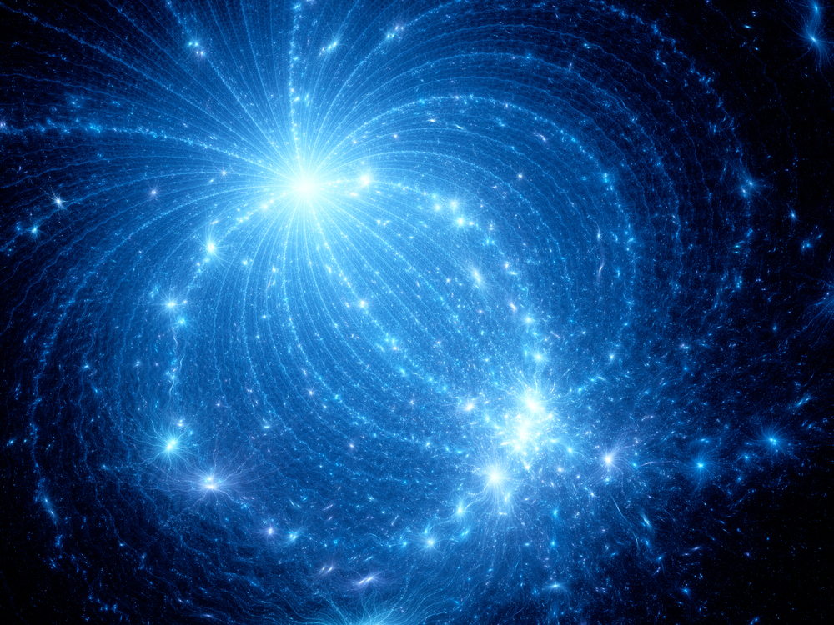

What the Bleep Do We Know?
I read my first books on quantum physics in the late 90s and found them quite fascinating. But I wouldn’t have been able to explain to you what I read, and the information seemed to fade away from me fairly quickly. There hadn’t yet been an explosion of teachers and videos on the Internet helping to explain the experiments, the theories, and the significance in our everyday lives.
The subject began to come alive for me when I saw the 2004 film What the Bleep Do We Know? The film was released around the time of my ten-year wedding anniversary, and I suggested to my husband that we head into the city for our evening out. And so it was in Seattle’s eclectic Capitol Hill neighborhood that I found myself captivated by this film — which combined expert interviews and a fictional demonstration of how the concepts play out in a person’s life. It was exhilarating! (My husband fell asleep, an apt and poignant example of a couple whose interests and passions are no longer aligned.)
How fitting that I was in a theater that felt special since it was the film’s theater scene that has stuck with me. To this day, I have a picture in mind’s eye of the main character standing in an elegant theater, watching multiple versions of herself walking by, displaying different emotional tones and accompanied by different people.
What a brilliant scene that was in helping to show us how some quantum physics principles are applicable in our everyday life. To be able to visualize different versions of ourselves playing out multiple possible choices is an excellent way to demonstrate the infinite potentials that always exist.
Nothing is static and set in stone. On the contrary, quantum physics shows us that everything is energy and potential. The material manifestations we have focused on are like seeing ocean waves. Those don't arise and stay stuck in one place. They arise, and then return to the sea, arising and returning to the sea of potential over and over again.

The film also introduced Masaru Emoto's astonishing work on how water reacts to emotions, Joe Dispenza's powerful experience with quantum healing, and other inspiring teachings.
Dr. Masaru Emoto, the Japanese scientist who revolutionized the idea that our thoughts and intentions impact the physical realm... studied the scientific evidence of how the molecular structure in water transforms when it is exposed to human words, thoughts, sounds and intentions. The extraordinary life work of Dr. Emoto is documented in the New York Times Bestseller, The Hidden Messages in Water… Dr. Emoto demonstrates how water exposed to loving, benevolent, and compassionate human intention results in aesthetically pleasing physical molecular formations in the water while water exposed to fearful and discordant human intentions results in disconnected, disfigured, and “unpleasant” physical molecular formations. He did this through Magnetic Resonance Analysis technology and high-speed photographs. (source)

Everything Emerges Out of Cosmic Potentiality
The visible world around us exists because an underlying field of invisible forms defines the potential of the world … Everything that exists in the visible world has first existed as a state in the cosmic field of potentiality.
Nothing comes out of the blue; everything emerges out of the cosmic potentiality. We build our dreams, hopes, and visions on what is possible: finding perfect love, ending war and violence, feeling the presence of God.
What would be important to learn, if it can be done, is how to use our mind to tap into the cosmic field of possibilities, in order to make our dreams a reality.
– Lothar Schafer, Science & Nonduality
Infinite Potential: What Quantum Physics Reveals About How We Should Live

Step-by-Step, In All Ways, The Possibilities Are Endless

Although the information in the film was a stretch, my life experiences over the previous ten years were resonant with the explanations the experts gave.
By that point in my life, I’d experienced what seemed like miraculous outcomes from learning how to create a more natural, organic lifestyle in harmony with human biology. I’d made countless positive changes that brought my children and me complete turnarounds in physical and emotional health. For example, for years and years, I used dozens of different homeopathic remedies for treating an endless array of childhood illnesses and injuries among my three children, and yet materialist science has no basis from which to explain the life-changing effectiveness my family experienced.
I’d also started yoga and meditation and had worked through a grueling period of trauma healing with numerous therapies including mind-body and energy healing modalities. Having done all that work, my children and I were healthy and I was feeling more centered and aligned with my purpose, more peaceful and joyful in the present moment, and optimistic.
So, with that groundwork of health and balance, and then seeing this film, my evolution really started speeding up. All sorts of fascinating new possibilities presented themselves and began to manifest.

Mainstream Science Has Been Wrong for a Long Time
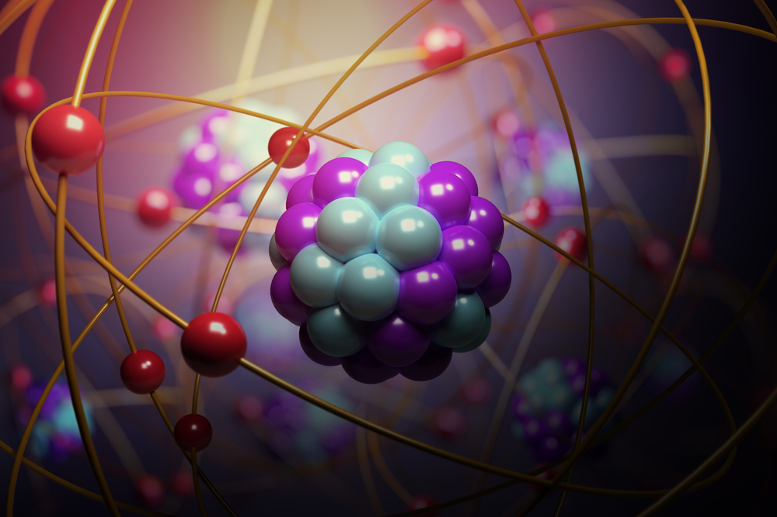
I didn’t attribute my life’s unfolding to the truths inherent in quantum physics. I viewed my life, my choices, and consciousness in general from a spiritual and philosophical perspective as opposed to a scientific one. This is due in part because I was taught the mainstream science of the time: materialism.
If I had tried to apply a scientific lens to what I was experiencing, it wouldn’t have been possible since I was still holding the outdated materialist viewpoint — which not only can’t explain what I was experiencing but actually implies it’s not even possible.
For example, the image above is similar to what we were shown over and over again as students of the mainstream educational system. We’re built from atoms, they told us. Atoms are the smallest thing… there’s nothing physically smaller, and so the implication is that there’s nothing else to find. And what are atoms? Why, they’re physical things that have parts we can name, just like every other physical thing we describe. These parts are called electrons, protons and neutrons. The implication is that these are kinda like bouncing balls that we see with our physical eyes.
All matter — be it solid, liquid, or gas — is composed of atoms. An atom is the smallest unit of matter capable of retaining the identity of an element during a chemical reaction. An element is a substance that can’t be broken down into simpler substances by normal chemical reactions. (Atoms and Elements in Physiology and Anatomy)
This is grossly misleading. We’re not made of little physical particles that behave like the balls we see on the playground. We’re made mostly of space (aether) and the smallest stuff is not material but rather energy waves that sometimes take the form of particles. And those particles don’t act like bouncing balls we see with our eyes. They act in wondrous ways that quantum physics can teach us about.
The physics of the microrealm involves two famous and bizarre concepts… it is impossible to know with certainty the outcome of a measurement on a particle; rather the particle exists in a ‘superposition’ encompassing multiple mutually exclusive states. So, a particle can be in two or more places at the same time… The second involves ‘‘entanglement,’ the spooky link that can unite two objects, no matter how far they are separated. Both superposition and entanglement are described mathematically by quantum theory…. quantum theory may not be the final word on describing reality, inspiring physicists to hunt for a more fundamental framework. But any such ultimate theory must still incorporate superposition, entanglement, and the probabilistic nature of reality, since these features have been confirmed time and again in lab tests. (source)
I found mentors and guides that shared knowledge far beyond what I’d been taught in school. All I had to do was withhold judgment and try things with an open mind, forgetting the limiting view I’d been taught in 16 years of schooling.
To some extent, all languages have a built-in hidden ideology, washing people’s brains in a way that they don’t notice. Materialism — that is, the belief that only matter is real — is a brainwash of our language that tells us that only materialism is a reasonable way to look at the world… Niels Bohr, for example… brushed aside the strange aspects of the quantum world by claiming that they had nothing to say about what reality really is. It is wrong to believe, he argued, that our experience of the world can tell us what the world is like… If your observations don’t make any sense, just forget about them.
– Lothar Schäfer
Science & Nonduality
The quote above is pointing to not only a dismissive attitude regarding personal experience, but the fact that some scientists believe it’s okay to ignore evidence which they or the establishment can’t explain, even when obtained in controlled environments. This is why we find anomalies in science, including astronomy, biology, chemistry, physics, geophysics, archeology, and psychology. An anomaly is, by definition, something that occurs outside the accepted paradigm. Therefore, by definition, an anomaly is a model-buster — evidence that the proposed theory is incomplete or inaccurate. In medicine, the words are “miracle,” “remission” and “the placebo effect.” These all point to the fact that the model being presented doesn’t account for what has actually happened and therefore the theory is incomplete or inaccurate. If professionals continue to teach such a model as wholly correct, they’re passing on something that is incorrect since it does not account for the anomaly.
It may help to remind ourselves that a model is, by definition, a representation of something else... a simplified way to explain how something works. Even in science and medicine, a model isn’t the thing; it’s a way to explain the thing. The purpose of scientific research is to test a hypothesis about how something works. Based on the outcome, theories are proposed. A theory is another name for model. It’s a proposal that endeavors to explain how the thing likely works.
If and when new evidence is found that contradicts the model, the model needs to be set aside and efforts realigned not toward doubling-down on the model but toward understanding what is actually happening since the model isn’t explaining it.
If one cannot yet envision a model that would account for all the evidence, then the task is to ask questions and test hypotheses while awaiting the lightbulb moment that ties everything together into a model that can then be tested.

An excellent example is in this video where Nassim Haramein contrasts the Copenhagen interpretation of the double slit experiment in quantum physics with that of De Broglie and Bohm. He explains that to accept the Copenhagen interpretation requires us to accept a cat being both dead and alive at the same time, not to mention bringing up all sorts of questions about the consciousness of fleas and what not. If we set the Copenhagen interpretation aside, we can consider new theories. The De Broglie and Bohm interpretation takes a different approach and posits the existence of aether which is being affected by the experiments. The math still works, the model accounts for all evidence, and it makes a whole lot of sense.
A number of people in establishment science and medicine have convinced themselves that a model is more important than the facts. We might presume that the money and power of corporations and institutions are at the root of such nonsense. Having a closed mind is a personal choice, but when powerful influencers have closed minds, they are educating generations of children and determining where public funds are allocated.
Never is a model a replacement for reality; it’s just a model. The key here is how learning an incomplete model as “truth” limits our minds to the greater truth.
The outdated materialist worldview is a prime example of hanging onto an incomplete model despite endless unexplained phenomena and “anomalies.” When I pictured matter, including my body, being made of little particles acting like bouncing balls, I didn’t have a model that could account for all the “miracles” in my life. And for some people, that prevents them from trying things that could give them those same miracles, simply because they’ve been taught it’s not possible.
Quantum physics made nonlocality and entanglement a part of the scientific lexicon, which immediately called materialist science into question, and yet here we are, nearly a hundred years later, still trying to free our minds from the outdated perspective we were indoctrinated with, believing that only the table and chair is real, not the energy we can’t see.

When Things Don’t Add Up, Check the Assumptions & Question the Models

The idea of something measured in one place “influencing” measurements far away challenged what Einstein thought of as “local reality.” It came to be known as “nonlocality,” but it always contained something else called “nonseparability.” (source)
Nonseparability in the quote above is usually called entanglement, referring to stuff far apart affecting each other. Einstein's comment has become quite famous and is shared widely.
Though it has been confirmed numerous times since 1935, entanglement is as spooky as ever. (published in 2010)
Einstein died in 1955. If he were alive today, do you think he’d STILL consider entanglement “spooky?” Or would he have used the scientific knowledge of entanglement to think differently about how things work?
Einstein was born in 1879. In 1887, the Michelson-Morley experiment seemed to disprove the existence of aether, and so Einstein formulated his equations without an assumption of aether which had been standard up to that point. But then in 1924, more than thirty years before his death, Einstein wrote a paper called Concerning the Aether In which he reaffirmed his earlier presumption of the existence of aether:

We will not be able to do without the aether in theoretical physics, that is, a continuum endowed with physical properties; for general relativity, to whose fundamental viewpoints physicists will always hold fast, rules out direct action at a distance. But every theory of local action assumes continuous fields, and thus also the existence of an ‘aether.’
– Albert Einstein,
Concerning the Aether 1924

Thus, with the 1924 paper, we already see Einstein reconciling the evolution of evidence in his lifetime. And this particular subject, the existence of aether (The Field) is absolutely fundamental to how we perceive the Nature of Reality.
An understanding of aether is the basis for The Science of Oneness and an endless array of seemingly “magical” outcomes of energy medicine and other unseen modalities.
So returning to what Einstein called spooky in quantum physics. When we understand that all matter arises from and interacts with The Field of information and possibility (what we might also call consciousness), then it makes much more sense that everything is connected. And it’s just a small jump in understanding to see how such a universal connection would involve “entanglement.”
Things are only spooky if we don't understand them. And we can only understand if we let go of incorrect models that limit our understanding.

Our World is Much More Exciting Than We’ve Been Led to Believe

The Mandela Effect
Fourteen years after that pivotal moment in a city theater, I was hanging out in a sunny suburban kitchen with my late-teen sons, when my materialist beliefs were fully exposed and obliterated. Up to that point, my life had already changed so much that it hardly seemed related to the one I led before. I’d been experiencing life changes that were wildly challenging to navigate, but it was all for the best. I was grateful and feeling at peace, thanks to yoga, energy healing and my spiritual beliefs. It was basically faith — not science — that had grounded me each time I stepped into the unknown.
Still, even though I knew nothing of the science going on “behind the scenes,” my life was nevertheless the reflection of such scientific truths as the interchangeability of energy and matter (Einstein’s famous equation), the pivotal role of vibration and frequency, and the powers of nonlocality and entanglement. But it would still be many years before I could digest that type of knowledge. What came first for me was a crazy implication of all that powerful science that has been called “reality shifting.”
It was the Mandela Effect that broke through the terribly limiting science “education” I had received (more aptly described as a “materialist indoctrination.”) The Mandela Effect is a consciousness-altering example of how our lives and that of the human collective can see quantum physics, or “reality shifts” in action.
Cynthia Sue Larson is a teacher who is not only adept in quantum physics, but since 1999, she's been researching and writing on one particular aspect of the nature of reality that might be called Reality Shifts, the Mandela Effect or Quantum Jumping.
It can be interesting to reflect on the fact that Truth is true even if we aren't aware of it. The forces that quantum physics describe to us have been acting on our world, whether we knew it or not.
There are lots of Mandela Effects videos available now but I wanted to share something from Larson since she has played such a vital role in tracking, understanding and reporting on this powerful phenomenon with neutrality and context. She’s not always the most engaging speaker but I appreciate her work and her books very much. However, when I looked for a video of hers to share with you, I found that most of them included a bunch of additional information that, when you’re first exposed to this subject, can muddy the water. And so it was only this 7-minute video that described it simply without extraneous information and, so, is a good place to start. Then, if you’re interested, you’re likely to find dozens of more options on the Internet by other people reporting on this fascinating phenomenon.

Paying Attention Allows Us to See the (Sometimes Shocking) Magic
That sunny morning in my kitchen in 2018, I got irrefutable evidence of a reality shift in my life, and it brought me to my knees. I’d been awed by what I’d been learning about the Mandela Effect but it was the moment my son’s friend read from her phone about the Berenstein / Berenstain Bears shift in our collective history that my knees literally buckled and I slid down the kitchen wall to the floor. "What's happening?” I thought.
For YEARS of my life, I read Berenstein Bears books to my kids, and I know exactly how the name was spelled because I pondered countless times whether it was pronounced Beren-STEEN or STINE. So when I learned from Mandela Effect researchers that now our collective history says that the books are BerenSTAIN Bears and always has been, I was dumbfounded. To make it even more surreal, shortly afterward I found myself in a dentist office, waiting for my son and saw a pile of children’s books. I picked up a book to see with my very own eyes the books I had read a gazillion times which then were called Berenstein Bears to indeed now be called the Berenstain Bears.
It’s funny what the body does when you experience or learn something that you didn’t think was possible. It’s kind of like my experience with earthquakes. I grew up in Alaska where earthquakes are relatively common and when one is powerful enough, things around you don’t act right… previously horizontal surfaces can tip or roll, stuff falls off shelves, floors can roll, walls can shake. It’s so surreal that sometimes my stomach would drop and it would begin to feel like a dream.
Learning that something I personally experienced was no longer acknowledged in collective history was as surreal as any earthquake I’ve experienced.
But most of the time that I’ve experienced “magic,” it wasn’t quite so disorienting… for example, when one of my sons was only four years old, he would have nausea and vomiting spells that wouldn’t stop… and I mean, literally, wouldn’t stop. Even just after vomiting, the nausea would continue. It would go on and on and on… and it was absolutely horrifying. Mainstream medicine had nothing to offer me except to NOT give him any water… and then if he were to become dehydrated, they would give him an IV. What I found would get the nausea and vomiting to stop was a homeopathic remedy and acupuncture. Both of these are forms of energy medicine that mainstream medicine can’t explain and doesn’t offer, so I never again looked to mainstream medicine as my primary resource for health and wellness. As a result, I found magic everywhere: most especially from my naturopath, my food pantry and my organic garden, but also in shamanic wisdom, Chinese medicine, and more. By putting my attention on new things, I got wondrous results.

What Does It All Mean and Why Should We Care?

The Field Brings It All Together
Aether… quantum physics… water crystals being affected by words, music and emotions… the power of energy healing… the reality of spontaneous remission and “miracle” healings… the power of natural foods, yoga and spirituality… the Mandela Effect… are these a bunch of separate truths?
I’ve always believed everything can be connected but for most of my life, I haven’t been able to grasp and articulate the underlying principle that connects it all.
We are blessed to now have access to so many teachers. Thanks to Nassim Haramein and other scientists, we can see that when Einstein told us in 1924 that he believed in the aether, he was handing us the key to escaping materialist indoctrination and opening to infinite potential.

Max Plank, another great scientist, called aether “a force” and “a conscious and intelligent Mind.”
As a man who has devoted his whole life to the most clearheaded science, to the study of matter, I can tell you as a result of my research about the atoms this much: There is no matter as such! All matter originates and exists only by virtue of a force which brings the particles of an atom to vibration and holds this most minute solar system of the atom together… We must assume behind this force the existence of a conscious and intelligent Mind. This Mind is the matrix of all matter.
- Max Plank
Nobel Prize Winner in Physics and known as the Father of Quantum Mechanics

Plank isn’t the only person to have used different terminology to describe this same Force.
As it turns out, aether, consciousness and your true essence all have the same definition… who knew?
In fact, I've found so much overlap in terminology for this concept that I began creating a list of synonyms. And that's when a light went on and the door opened wide for me to more easily understand virtually every science and philosophy on the planet that touches on Consciousness or The Nature of Reality.
I've found that all the following are virtually identical:
- Aether
- Quintessence
- The Field
- Quantum Field
- Plasma
- Spacetime
- The Fabric of the Cosmos
- The Void
- Akasha
- The Universe
- Spirit
- Consciousness
- Fabric of the Universe
- Primary Principle of Existence
- Universal Phenomenon
- Eternal Driving Force for all that Exists
- True Essence
- True Nature

Clearly, not all those words can be used in place of the other in the many contexts in which they're used. The different words have value in conveying distinctions that represent bodies of knowledge that provide different lenses or perspectives. Some have aspects of meaning that are more applicable in some situations than others. But let's consider how many, many people have needed a name for this important "thing" they wanted to describe, explore and discuss.
Surely the depth, subtlety and pervasiveness of this thing we call consciousness and our true essence is worthy of so many amazing words and perspectives. Whether the source is ancient wisdom, yogic philosophy, quantum physics or other science, the variety of offerings contribute so much to our world.
And this is key...let's be clear on the fact that all those sources are speaking of the same thing! If we think those 18 words speak to unrelated subjects, we remain ignorant of how many people are actually in near-total agreement about the core knowledge at the heart of this vital subject of Consciousness and the Nature of Reality.... which is what again? Oh, right, the essence of who we are and the essence of every "thing" that exists.
For example, Vedic teachings (estimated to have been written between 3,000 and 6,000 years ago) have at their basis the notion that the universe is composed of five elements or panchamahabhutas (earth, water, fire, air and ether). The five elements form the basis for Ayurveda, the “sister science of yoga.”
No matter whether we align more with scientific of philosophical teachings, we are constantly interacting with the Field of information (with aether, with consciousness) and it is from this field of infinite potentiality that we experience our life.
We are in the midst of waking up from a dream of being victims in a universe where matter arises randomly… to becoming awake to the nature of reality, consciously interacting with the Field, and making choices that dramatically impact how the potentials materialize.
For thousands of years, the Aether (ether, æther, aither), a field which connects and permeates all things, was an essential facet of both the philosophy and science of reality in cultures around the world.
– Adam Apollo
Resonance Institute
See Also
- What is Consciousness?
- The Nature of Reality & Science of Oneness - Introduction & Terminology
- The Nature of Reality & Science of Oneness - Overcoming an Outdated Worldview
- The Nature of Reality & Science of Oneness - The Science
- Consciousness Expansion, Raising Your Vibration or Frequency, Ascension

