AN ESSAY TO SHARE

The Failure of Systems. The Power of People.
The Case for Going Local
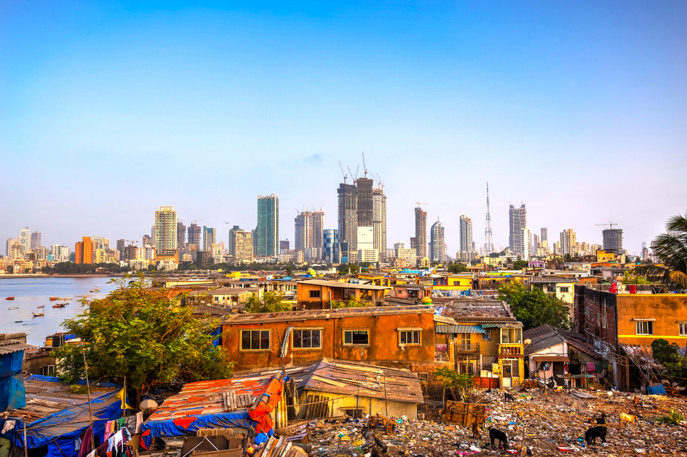
An essay you can share or copy from and make your own
by Shelly Thorn
v 2.2

Table of Contents
Where We're At: It’s Not Where We Want to Be 3
Our Inheritance 3
Seeing Through the Propaganda 4
Our Recent Past: How We’ve Contributed to Our Present 6
We’ve Tried Dang Hard To Be Good Citizens 6
Our Failed Strategy? Working With and Trying to Fix the Systems 8
Moving Ahead 10
Stop Investing in Systems and Invest in Humanity Instead 10
Going Local 12
Big vs. Small, Global vs. Local 12
You Could Do One Thing to Experiment with Choosing Local & Small 13

Where We're At: It’s Not Where We Want to Be

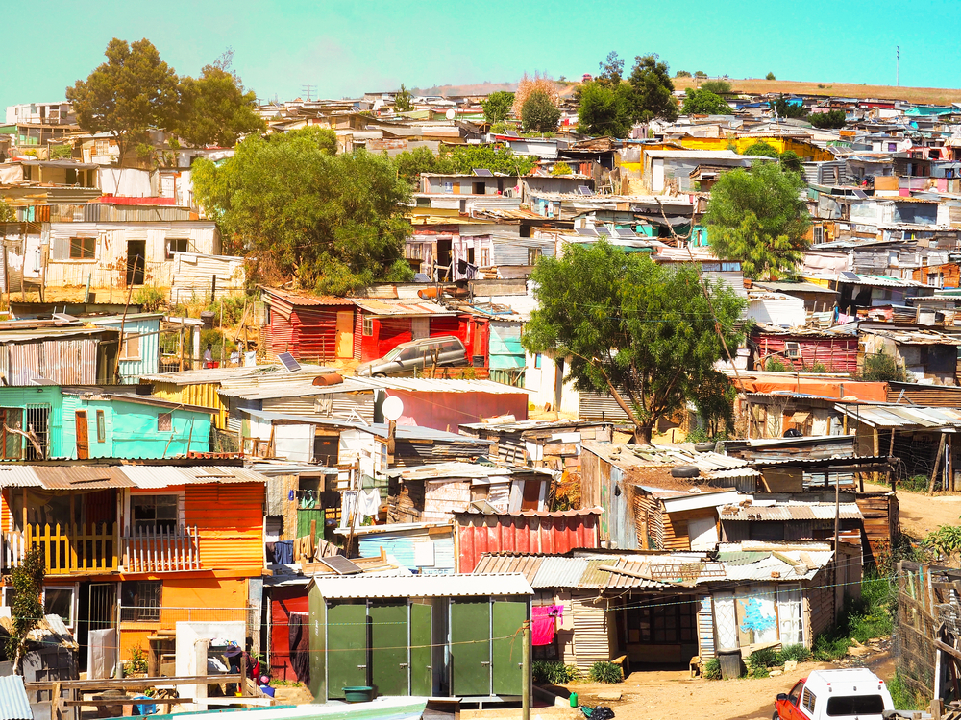

Our Inheritance
You and I were born into societies with existing systems: banking and currency, corporations, governments, armed forces, schools, media.
We didn’t choose these systems. We inherited them.
The systems didn’t come along with a prosperous and beautiful world, thriving cultures and leadership by wise elders. Far from it. We were thrust into a world that can’t even ensure basic survival needs are met, much less that we have a safe, smooth way for people to interact with each other, develop their gifts, and revel in the glory of this gorgeous planet.
The majority of the world's population is traumatized and struggling amidst poverty, stress, war, cultural desecration and ecosystem destruction. This is not to say that there isn’t also amazing beauty in the world, but that the systems have failed us.
It wouldn’t be surprising if you haven’t thought much about that since we’re constantly being told that the faults of the world lie not with these big systems, but with humans. We’re the problem. We need to work more, vote more, know more, give more, buy more, accept more. But, most especially, the problem is particularly because of some other group of people who have different beliefs, culture, economic status or SOME difference that explains why it’s THEIR fault.

Seeing Through the Propaganda
We’re all exposed to different information based not only on media and information choices but also upon less obvious influences including where we’ve lived and traveled. And no matter who we are, we’ve been exposed to pervasive propaganda (and disempowering beliefs) of various types. For example, many people on our planet have been groomed to believe one or both of the following:
- Sure, we’ve got problems here in our country, province or state, but the problems are much worse elsewhere. You’re extremely fortunate because it's much better here (wherever “here” is).
- Other powers determine your fate. (Depending upon the subject, it could be financial markets or stockholders… social or ruling classes… corporate leaders… state regulations… federal agencies… other countries’ governments… or the need to sacrifice so we can defend ourselves against crazy people in another country or a part of our own). You’ll suffer less if you stop fighting against an unwinnable system and accept things as they are. Then you’ll have a chance at being happy.
Those statements reflect the results of being at the mercy of propaganda for a very long time. And when we consider the results of such beliefs, we see how effective they are at keeping the systems from being held accountable.
I experienced an interestingly different angle on propaganda recently. I found it quite strange that during a conversation with a brilliant South African marketing executive, she made a sudden change from her typical comfortable confidence to a more humbled, almost apologetic, demeanor. This change occurred as she mentioned something in passing about how things work in a “third world country.” In that moment, I could see that she held a belief that something must be less-than about her business or her competence as compared to “first world countries.”
I found it appalling that someone might believe that a country with fewer paved roads or less money in the central bank could mean that the people or their competence was “less-than.” I understand that there are certain bureaucratic systems that have (historically) worked smoothly in the U.S. (but usually only if you have money to pay for fees and attorneys) while some countries, (including South Africa) have notoriously obnoxious government bureaucracy and, in some cases, severe corruption. But how could governmental bullshit make an independent businesswoman feel second-class based on her country of origin?
To learn more, I looked up the phrase and this is what I found:
The phrase ‘Third World Countries’ originated in 1952 during the time of the Cold War. Alfred Sauvy, a French economic historian, coined the phrase. With the world dominated by two camps, Alfred used this phrase for another group of nations that neither supported the communist nations led by the Soviet Union or the USA and its allies. At times, Third World was taken to be synonymous with the nations that were members of the Non-Aligned Movement, while at other times the term included nations that had a history of colonial rule. (source)
So the original usage of this phrase doesn’t even have valid meaning today! It was related to political alliances in the 50s, for God’s sake. We don’t need to be using a name that sounds like a debasement but in fact refers to at one time having been neutral in politics and invaded by oppressors. That’s insane.
We could discuss propaganda for a long time, but here are just a few key points:
- We swim in a sea of propaganda. It's so pervasive that, without great conscious effort, you’re automatically filled with beliefs that disempower you. Why? Because the purpose of propaganda is to influence you, to get you to support the agenda of a system. The fundamental objective behind any communications or actions of a system is to continue the system’s existence. This is done by convincing you that, for example, you’re flawed in some way and so need what their selling, or that you need someone to look out for you and so you support their continuance and their power.
- We can see through some of the propaganda by traveling (even if only in your own state or country). Talking with real people who don’t have an agenda and seeing things with your own eyes is a sure way to be surprised by how different things are from what you’ve been told.
- Independent journalists and researchers are absolutely key in countering propaganda. (Get the facts on the 6 businesses that own mainstream media here.)

The speaker in the following video is someone I find neutral, intelligent and pleasant. She gives a small taste of the things that many Americans are unaware of: How I See the US After Living Abroad for 15 Years [CULTURE SHOCK].

Our Recent Past: How We’ve Contributed to Our Present

We’ve Tried Dang Hard To Be Good Citizens
Okay, so the systems we inherited failed us, but we’ve had a role in this too, of course. Let’s do a quick recap of how we got here so that we can identify what hasn’t worked and what we want to try instead. Let’s review our recent past based entirely on our own observation and experience. No need for college words about economic policies or political ideologies.
At some point after watching our planet burn, most of us have come to realize that the systems running our world aren't doing an adequate job, and we want to change things for the better. So some of us began advocating for smaller government, some of us for bigger government, some of us for reformed government. Sometimes we became more loyal to a political party or even switched parties depending upon which one was being portrayed as finally, truly, getting to the heart of the problems.
Some turned away from government to work with businesses that seemed to have a conscience. Some turned to non-governmental organizations (NGOs) to fill in the gaps and pick up the pieces. Red Cross, UNICEF, World Health Organization, GreenPeace., and thousands of other organizations seemed to be the answer to balancing out all the need left by governments, militaries and corporations. At times, when we could spare any money, we would donate to research, NGOs, or the current charity being highlighted in the media. In a world where everything is so big, especially the problems, this seemed one of the few ways to potentially make an impact. We hoped our small contributions were adding up to make a difference, and we would sigh with relief each time a gazillionaire philanthropist stepped up to save the day with Big Money that would surely make a problem go away.
Through it all, as a collective we kept relying on the same underlying systems (of corporations, government, armed forces, media, NGOs), figuring we just needed the right combination of personnel and resources to finally get things right. When an “up and coming” politician was paraded in front of us as a Real Savior, we'd lap it up, excitedly working to "get out the vote" because, finally, we had found the One who would hire the right people, cut through the red tape, and lead us out of this mess. When an exciting startup like Apple, Microsoft, Uber or WordPress was lighting up the world, we’d turn our attention there, thinking that their ingenuity was somehow going to show our societies the way forward.
After the failure of every corporate promise, political "hero" and party "solution," it felt like we were finally trying something new when we put our faith almost entirely into technology. Advanced technology has a way of always feeling exciting with great potential, so it's been natural for many people to believe that the technology in and of itself is powerful enough to fix what’s broken. Even when told how it can be misused and harmful, we turn away from that, willing to pay virtually any price because we know for sure that we need a new way to solve our societal problems. And so, we entrusted our power in the latest version of savior: high tech. But soon, high tech came to be controlled by an ever-lessening number of massive corporations and used by the same governments that took all our money and faith and the best people we could find, and had never solved the problems before.
Meanwhile, even though everything seemed to be going to hell in a handbasket, we figured we could at least rely on governments, organizations and the media to be our watchdogs, to inform us if anything too insanely horrendous was going on. Surely, we could at least get that much from them. Besides, it's not like we could do this ourselves. First, we're just individuals – miniscule compared to the power of corporations and governments. And second, we've been too busy trying to pay the bills, recover from stress, manage our health and squeeze in some fun and satisfaction to oversee the big systems. We seemed to have no choice but to empower political and legal systems to take care of our world for us, to trust they would stop any organizations found to be misusing its influence and to strip perpetrators of the power to cause further harm. (I won't bring you down with their failure in this area. But when you're ready, you can begin with the basic foundation here.)

Our Failed Strategy? Working With and Trying to Fix the Systems
I’ve asked myself so many times, especially in the 80s 90s and early 2000’s, where should I put my attention and energy to be of maximum service? So many times I thought that surely if a bunch of us are doing our best, we’ll contribute to a way of life that becomes more effective and sustainable, and our world will become the beautiful place we all know it can be.
And yet here we are. Poverty, stress, war, rampant corruption, cultural desecration and ecosystem destruction are just some of the outcomes of these control systems. What more do we need to know? Why continue to throw money and energy at bloated systems that have had plenty of opportunity to prove they could serve us, but have not only failed to improve things, but have made them unimaginably worse?
As reasonable as it’s been to support the systems we were given at birth, it’s been an abject failure.
Despite so many people trying so hard (whether to be a good corporate manager, to get a second job to put food on the table, to serve on the board of a nonprofit or to get the right people into local government), things in the world haven’t gotten a little bit better, they’ve gotten far worse. How is that even possible?
Watching this worsening madness with growing confusion, I could only make sense of it when I finally changed an underlying assumption that the systems are our only option. Once I could see the systems with more objectivity, I could see that they hadn’t been working in our best interests for a very long time.
I saw that not facing this fact and trying to fix them with the latest promise was like taking pain relievers that cover the symptoms but don’t heal the cause. At some point the pain relievers will barely work anymore and may cause ever more side effects, while the ultimate cause becomes more entrenched and dispersed.
We’ve been following a strategy of giving our power away to the big systems and believing their propaganda that they’re taking care of us better than any alternatives.
The power of those systems has gotten SO great, and human energy and ingenuity has been SO misdirected and disempowered that the deterioration of human societies is accelerating at a dizzying pace.
I know in my heart and from experience that people are absolutely amazing and full of energy, creativity, power and dedication. But if you tie their hands behind their back through trauma, addiction, disease financial stress and cultural demise, they’re unlikely to direct their power properly and will feel they must rely on the systems. Meanwhile, all that amazing human energy is suppressed. And at times, all that suppressed energy turns on itself and everything around it.
The key we must remember is that the entire driving force of systems is to continue the survival of the systems. Corporations and governments in their current form exist not to serve us or our mother planet, but to continue to exist.
With an unwavering resolve to sustain themselves, the systems have ultimately turned US against OURSELVES.
Now those systems are collapsing and many people (me included) think it’s time to let them crumble, while we turn our attention to building new solutions.

Moving Ahead

Stop Investing in Systems and Invest in Humanity Instead
Here’s the thing: systems only have power because we fuel them with our minds, our bodies, our attention, our money, our commitment, and our acceptance and defense of them.
When we take our power back, the dysfunctional systems dissolve. This must be so because everything is ultimately fueled by humans and our will. Everything is powered by the will of people (unless we give our power away to AI which then, as so many dystopian movies have shown us, our will may be thwarted by a self-sustaining system of such magnitude that we struggle to regain our sovereignty).
(See more on how the proliferation of inhumane and dehumanizing systems calls us to distinguish between organic and artificial ((life-supporting and life-degrading) activity.)
Distinguishing between human and systemic or artificial has had an amazingly positive impact on my life. One of the wonderful results is that it has restored my faith in humanity… because now I can see how the systems have taken away people’s power while rewarding sociopathic and inhumane behavior. (This is really significant… everyone should be well-versed in the use of compartmentalization & hierarchy, NDAs and censorship)

There is great benefit in differentiating between:
- Human Qualities & Values … vs … Artificial Qualities
- Humanity … vs … Corporations
- Consciousness … vs … AI Algorithms
- Alignment with Our Mother Planet … vs … Pillaging for Short-Term Gain
- Journalism … vs … Mainstream Media
- Health & Wellness Care … vs … Symptom Suppression & Corporate Medicine
- Empowerment … vs … Power Over
- Service, Mentorship & Leadership … vs … Power & Control

And so, I hold and invite you to a vision for the future of humanity:
Small, local sustainable communities living in harmony with the Earth.
In sustainable communities, any technology and systems we employ are designed with human checks and balances to ensure they serve our organic, conscious alignment with the Greater Whole.
We begin by simply, as individuals and families, learning step-by-step how to live holistically and sustainably. With each step we take, we become more capable of recreating our societies in a healthy way... to rebuild our small, local communities so that we can take care of each other and our part of the Earth.

Going Local
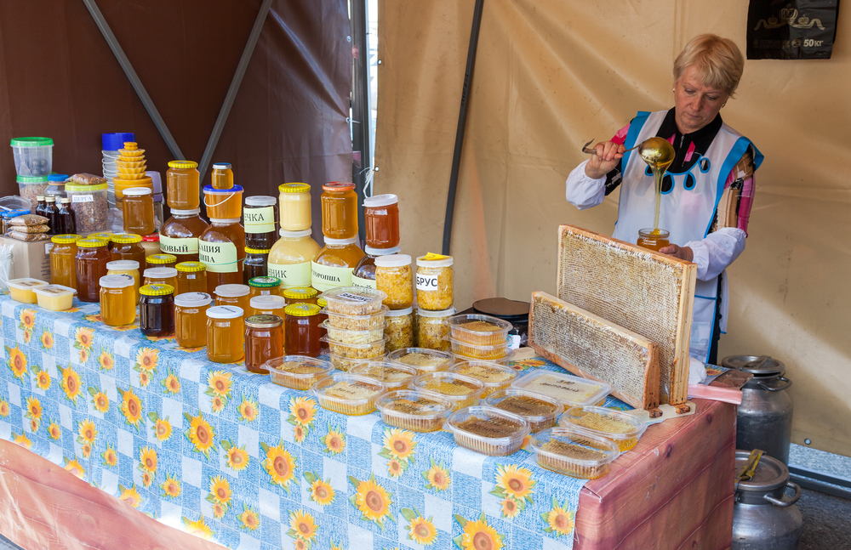
One of the many reasons I support small and local businesses is that I can see with my own eyes how they do things. This tends to prompt questions about how exactly big businesses get perfectly shaped "briquettes" or the same size and color of tomatoes or what they do to herbs to package and ship them so far away.
As my knowledge of big business grew over time, I came to have an ever-growing list of reasons to support small and local... have you experimented with that?

Big vs. Small, Global vs. Local
Experience over the past few decades has shown me that I can promote my family's health and well-being, and that of the planet, by supporting small business and local everything (local food production, community-building and decision-making). When I buy small and local, I experience these sorts of benefits:
- I get fresher food which means its far more nutrient-dense, as nature offers us.
- I eat more in-season, also as nature intended, supporting my body in its organic interaction with the climate I'm interacting with.
- I help to keep my neighbors receiving income which supports my entire local economy.
- I can directly support providers that I know for sure use sustainable methods and do not pollute or toxify soil, air or water.
- I support the production and delivery of food that will sustain my community without need for shipping from afar. "Supply chain issues" aren't a thing when a local community has developed itself.
I avoid supporting corporations and big businesses because:
- By definition, corporations are non-human entities where people are not held responsible for actions made on behalf of the business.
- People acting on behalf of big businesses are only employed if they act in specified ways that prioritize continuation of the entity. In other words, they are not sovereign but are controlled.
- Corporate managers and employees are not only released of liability and disempowered from their naturally sovereign state, but they are limited by extensive regulations and procedures and are therefore not in a position to use the full powers of their creativity and innate compassion for sustainable problem-solving.
- Corporations are by definition and design non-human entities that worship and strive for power. People exhibiting humane traits may be present here and there, but any power they have is vastly superseded by the primary objective: sustaining of the entity. Thus, corporations are set up to be corrupted. Corruption is the abuse of power for personal gain. This is the opposite of being fair and humane. It's much easier to succeed in corrupt activity within a large, compartmentalized, non-human entity than with a small business owner who has many other priorities along with sustaining their business. In fact, research has shown that 1 in 5 CEOs are psychopaths.

As I see it, humanity was duped into thinking the creation of these entities would make the running of our world better, but the result has been a disaster in every way.
People in local businesses, on the other hand, are far more likely to not only wish to continue their business, but also to do so by living in harmony with their neighbors and their environment. They are responsible to their community for their decisions. They live next to the people they serve. They know what people in their town need and want. They'll hire their neighbor's teenager for the summer even if that is slightly less efficient than a different hiring decision. They know that if their business was to pollute the local river, then their kids and food source would be harmed, so they're far more likely to build in costs to keep the environment clean. If a local group checks on them and finds they're polluting, they're more likely to fix the problem than hire lawyers to put off doing the right thing in their own neighborhood.

You Could Do One Thing to Experiment with Choosing Local & Small
In my opinion, local food and water security is the most important priority for every community on the planet, and when we turn our attention to this subject, we're rewarded beyond our expectations.
Corporate agriculture has resulted in land degradation, loss of soil fertility, loss of biodiversity, declining yields, malnutrition, declining livelihoods, reduced access to traditional wild food and loss of income among other damaging results. Reclaiming land and restoring soil integrity is vital for many areas. Food security is obtained by developing local food production via home and community gardens and moderately sized farms.
What one thing might you do? We can each act now.
- Buy locally.
- Plant a fruit tree or perennial herbs.
- Research water filters, solar panels or generators.
- Take a soup using local vegies to the new mother in your neighborhood.
- Convert a lawn or amend soil for conversion to a vegetable garden.
- Take a bag with you on every outing and pick up trash.
- Clear an overgrown or unkempt area to use for play, rest or connection with nature.
- Plan a weekly outing to the farmer’s market. Meet the farmers in your area.
- I propose everyone who can buy a produce share does so. If you're new to that, I think you'll be surprised by all that you learn and experience.
- Avoid doing business with corporations.
- Pay people in cash or barter services.
- Build a chicken coop.
- Take a child to harvest berries.
- And so on.

No matter how much or how quickly we succeed, it feels good to take back our power, act from our heart, give our gifts and help our neighbors. That good feeling signals the return of our God-given vitality and being in touch with our Soul.
In some cases, we're also dealing with some entrenched patterns based on harm created in the past. Get clear on what that looks like and what we can do in the essay, How Past Deeds Have Had Lasting Harmful Effects on Our Planet & What We Can About it Now .
Meanwhile, I hope that when the systems such as mainstream media or AI algorithms in your social media feed distract you and encourage you to blame fellow humans for the planet's problems, that you'll take your power back by ignoring them and turning toward what you want to create in the world.

