AN ESSAY TO SHARE

Become Aware of Where You’ve Given Your Power Away to Authorities & Systems That Shouldn’t Have It.
Choose to Reclaim It.
An essay you can share or copy from and make your own
by Shelly Thorn
v 1.2
Table of Contents
With every thought, feeling, word and action, you are choosing what you are empowering. 3
As a Youngster, Your Subconscious Mind Was Programmed 3
How the Subconscious Learns & Changes 4
How to Stop Running Subconscious Programs 5
How We Give Our Power Away 6
Outsourcing Power & Authority to “Society” 7
We Have Reasonable Reasons, Of Course 7
Misplaced Trust 9
Get Summaries & Links to Source Material 9
Inspiring Models 11
Other Ways of Living 13
Foundation for Intentional Communities: Directory 13
What You Can Do 15

With every thought, feeling, word and action,

you are choosing what you are empowering.

That is your free will and your ultimate power.

Have you thought about your power lately? Your innate power… your life force energy, your passion… your attention and focus… your physical abilities, intellectual approach, artistic perspective… your money, your influence… your care and support of others… your perspective, your imagination… the way you use your mind and your body, your potential. That’s a lot of power! How have you been using it?
Without a doubt, we all give a fair amount of our power away, both consciously and unconsciously. You might say we outsource it. Here we examine if some of that power is going to places that don’t deserve it.
If reading anything here causes your ego (a part of your mind) to feel a bit edgy or defensive, tell yourself that you don’t have to agree with anything or change in any way. This is just a discussion.

As a Youngster, Your Subconscious Mind Was Programmed
To be born onto planet Earth is to give away our inherent authority and power in big and small ways. How could we not? We were born into a baby’s body, helpless and reliant on caregivers for survival and connection. For many of us, our first two decades on the planet were spent under the auspices of parents or parental figures and other authorities: school teachers and administrators, sports coaches, arts teachers, police officers, doctors, employers and on and on.
It’s not as if, upon turning 18 or 21 or 30, that we suddenly stopped thinking and acting in all the ways we had been pressured or forced to by all those caregivers and authority figures. Sure, we might think we individuated in all the important ways, but looking closer, we find much we haven’t examined. Clues arise when we’re in new situations or under stress and find, for example, that we’re feeling anxiety that’s out of proportion, or we’re acting in ways that seem out of our control.
As a natural part of child development, we imbibed everything around us and filed it away in the subconscious. This is in part because our brains were in, basically, an altered state as youngsters. Dr. Bruce Lipton, stem cell biologist and author of The Biology of Belief, explains in the video below that in the first seven years of life, the brain operates at a lower frequency. During this time, the subconscious mind learns via a form of hypnosis, downloading what it observes.
As an adult, a person may be under the influence of the subconscious mind as much as 95% of the time.

How the Subconscious Learns & Changes
Lipton explains: Let’s say we read a book or watch a video and increase our knowledge. That is education of the conscious mind — but not the subconscious mind. Over time, we might “get really smart, but our life stays exactly the same.” Why? Because, as Lipton explains, the subconscious learns differently.
In the first seven years of life, the brain learns via a form of hypnosis, downloading what it observes. After seven years of age, the subconscious mind learns via:
- Hypnosis
- Repetition and habituation
- Tremendous emotional shock
- Belief change modalities associated with energy psychology that offer a form of “super-learning” or the ability to change long-held patterns quickly. He explains that there are many of these belief-change modalities, one being PSYCH-K, a process of synchronizing the brain hemispheres.

How to Stop Running Subconscious Programs
Subconscious programs go into effect when the mind is engaged in thinking about the past or future. During these times of thinking, the subconscious programs switch on so that we can continue to function here and now.
This points to one of the reasons why mindfulness practices such as yoga and meditation are so effective at transforming lives. To be mindful is to be present and to observe rather than to automatically react, or to run “programs.” This means that mindfulness and meditation result in
- More time that subconscious programs are NOT running, and
- Increased awareness of previously-subconscious programming.
Thus, mindfulness beautifully subverts automatic take-over by the subconscious. And, thus, we can get a sense for how increased mindfulness leads to such powerful growth and transformation.
With the resulting increase in awareness and the ability to step back from the programming, we are more able to engage in repetition and instilling desirable habits as a powerful way of RE-programming the subconscious with CONSCIOUS intent.
11-min video - 4 Simple Strategies to Reprogram Your Mind | Dr. Bruce Lipton
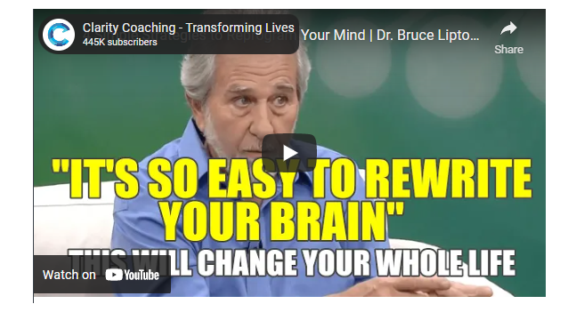

How We Give Our Power Away
We’ve given our power away in uncountable ways, sometimes unconsciously, sometimes with a sense of not having a choice, and sometimes willingly. For example:
I may not know I’m giving away my power when:
- I make a decision of where to apply for a job or which college, but had no idea that in other places it’s “normal” or expected that young people “find themselves” before making such long-term decisions.
- I don’t even think to research the information provided by a source that my family or social circle has been dismissed.
I may not want to give my power away but feel I have no choice, when:
- I must arrive to school before I’ve had enough sleep and sit in uncomfortable, hard chairs with harsh lighting that hurts my head, but I really want either the education, the approval, or the promises of future opportunity.
- To be in the military, I must give every ounce of freedom and power, but I don’t see another way to demonstrate my willingness to keep my community safe, or another way to get a job or education.
I may willingly give my power (of belief and action) to teachers, doctors, scientists, attorneys or other “experts” because:
- I choose to believe their perspective in exchange for saving the time of doing the work to form an opinion on the subject at hand.
It takes a concerted effort to get a sense for just how far-reaching the impact of previous experiences with authority figures and social pressures have been on our lives. It requires becoming conscious of the unconscious programming which may just appear as our beliefs. When we see how they came to be and “unlearn” them, we create space to become more aware of, and aligned with, our inner knowing and uniqueness.
Every one of us has given away our power to various degrees. So the question becomes, if we bring this subject to light, do we still wish to maintain the agreements we’ve been living by? During the year 2020, many people got a crash course in this idea when their lives were changed by outside forces, shining a spotlight on ways they had been living previously and providing them more time and space to question and make thoughtful decisions. For example, after being free of commuting, some people realized they no longer wished to spend hours each day in traffic. And some people found that spending more time in their living situation showed them it was actually unpleasant or unbearable (due to an unhealthy relationship or undesirable location, for example).

Outsourcing Power & Authority to “Society”
We’ve all been guilty of not speaking our truth to prevent discord, or acquiescing to the wishes of someone else despite a strong desire to act differently. While this may be with a family member, person in your social circle or a co-worker, here we’ll focus specifically on the experts, authorities and systems that we’ve given our power to, and how that looks.
How do we give our power to the systems and “authorities”? We outsource the authority to decide and act. In other words, we entrust a system or authority to do the right thing. (Sometimes we entrust them to do something on our behalf. Sometimes we trust them to be a representative of a type of knowledge.)
Examples of the experts, authorities and systems we entrust to take action using our money, our overt approval, tacit acceptance, or acquiescence make up what is often called “society.”
- National government
- Local government
- Corporations
- Technology infrastructure providers
- Finance professionals
- Media
- Medical doctors
- University personnel
- Scientists
- Researchers
- Attorneys
- Teachers or “experts” with stamps of approval from any number of organizations

We Have Reasonable Reasons, Of Course
We give our trust and faith to systems and experts for many perfectly reasonable reasons, such as:
- We learned that this is how society works, and so we follow the program. My family and neighbors send their kids to the public schools and I don’t have enough money for private school, so I, of course, entrust my kids to the local school authorities. My spouse likes to have the TV on and is annoyed when I turn it off, so I allow the news and ads to be the background in my life.
- The authorities promise or agree to help us individually or to help the collective or the environment. My local government has been elected and paid to keep our community safe and prosperous and so if I see the police force treating someone inhumanely, I must presume that their actions are in alignment with the entrusted power.
- The people we’ve hired or entrusted have received a form of authorization that implies they have more knowledge, capability or experience than people who haven’t received the stamp of approval. I have the symptoms of a serious disease and so, no matter what the medical doctor tells me, I trust the advice based on his university credentials.
- We believe that if we do not support an existing system, we put vulnerable populations or the environment at risk. Of course I don’t love politics and government. But what else are we going to do?
In short, we believe that the capability, trustworthiness and reliability of the experts, authorities and systems that currently exist are better solutions than any others we know of or could devise, and so we support them. In other words, we believe that however poorly the current systems work, it’s better than their dissolution.
Check out this easy-to-read but powerful Medium article by Kristin Wilson, The Pandemic Proves That Society Was Wrong About How to Live Life. Here’s What to Do About It.
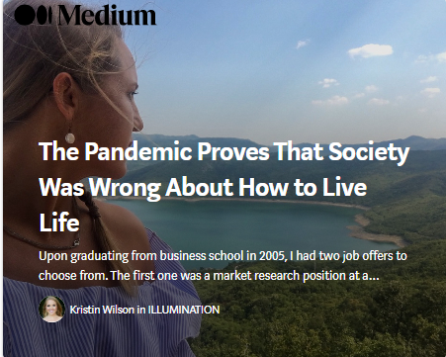
I’ve compiled a few outdated societal rules, norms, and assumptions worth abandoning from here on out… Lies society has told you about Your Career… How Business Works… Government & Institutions… Your Health… The World… How to Live Your Life…
Did you know that there are music producers who don’t know anything about music theory? Or that you don’t have to go to film school to become a filmmaker? Or that you could make six-figures freelancing online from Bali? What if flouting the rules wasn’t a recipe for disaster, but rather a road map for finding happiness and fulfillment in life?
– Kristin Wilson

Misplaced Trust
While there have been many good things done by many good people, systems (especially those under hierarchical control) have proven to be vulnerable to corruption, having been acquired and manipulated by a few small corporations. Mainstream media is a perfect example of the process of a system moving from journalism to narrative control.
When we peer beneath the surface of media and corporate narratives, there is endless proof that the largest and most mainstream systems today are not, in fact, trustworthy. Read more: The Failure of Systems. The Power of People. The Case for Going Local.

Get Summaries & Links to Source Material
- The Need to Reclaim Our Power: How Corporations Betray Humanity
- The Need to Reclaim Our Power: How Governments Betray Humanity
- The Need to Reclaim Our Power: How Modern Medicine and the FDA Betray Humanity
- The Need to Reclaim Our Power: How Researchers (in the Name of “Science”) Betray Humanity
For example, in How Corporations Betray Humanity, you’ll see such examples as:
- Pharma Lying & Manipulation — Seven research trials; six showed the drug doesn’t work. The manufacturer published only the one that had a positive result.
- Pharma’s Corrupt Practices Specified in Exquisite Detail — They give lavish gifts to physicians, promote new “diseases,” set up phony “patient advocacy organizations,” “educate” doctors about drug’s unapproved uses, bury studies they don’t want seen, and more.
- Nestlé, Coca Cola, Danone, Unilever — Big food corporations control markets while farmers and consumers are held accountable for the devastation.
- Pharmaceutical Corporations Intensely Target Med Students — Recognizing the formative nature of the clinical years of medical education, pharmaceutical companies seek to influence medical students years before they are ready to independently practice medicine.
- Big Pharma Are Big Lobbyists — Pharmaceutical corporations are among the largest lobby groups in Washington DC. How is government lobbying by corporations different from bribery and corruption?
- Pharma Targets Election Candidates — Pharmaceutical control tactics include lying about candidates up for election.
- Pfizer Has Been Assessed Billions In Criminal Convictions — If the penalty for criminality doesn’t change the criminal behavior, is the system working?
- Insulin Founders Gave Away Patent for $1 Because “Insulin Belongs to the World”— Pharmaceutical corporations monopolized the distribution of insulin, charging diabetics $750/month. See also: The High Price of Insulin Is Literally Killing People.

Big Food Corporations Control Markets While Farmers & Consumers Are Held Accountable for the Devastation
Large-scale food and beverage companies… play an outsized role in driving disparities in human health and environmental sustainability. Food processing companies currently make one-fourth of every dollar spent on groceries in the U.S., with just a handful of companies controlling as much as 98.4% of the market share in some categories of prepared foods. By comparison, the country’s more than 2.5 million farmworkers, the majority of which are undocumented and unprotected by fair wage laws, get just eight cents for every dollar spent on groceries.
Food processing companies like Nestlé (Switzerland), Coca Cola (U.S.), Danone (France), and Unilever (United Kingdom/Netherlands) are bottlenecks in the global food system, exerting undue influence over both what and how much is produced by farmers upstream as well as what and how much is eaten by consumers downstream… Despite this concentration of power and wealth, international agendas for public health and sustainable food production often call for reform not by the most powerful food companies but, instead, by farmers and consumers.
– Stop Blaming Consumers — It’s Time to Hold Big Food Accountable

Inspiring Models
Even with all the differences in our beliefs, we can all observe our own behavior regarding authority and power and consider how it’s been working for us and for others. Has what we’ve been doing gotten the results we wanted?
You may find it hard to believe that it’s possible to reject the systems that have betrayed us because these are the same systems who have the power and influence to inundate us with messages that they are the only way our world can work.
And yet there are so many examples of people making independent choices to create new ways of living with their family and neighbors. You might find some of these thought leaders and activists inspiring in their approach.
- Vandana Shiva — Has supported Indian farmers in achieving multiple successes with knowledge, community and teamwork.
- Rosa Parks — “In 1955, Parks rejected a bus driver’s order to leave a row of four seats in the ‘colored’ section once the white section had filled up and move to the back of the bus. Her defiance sparked a successful boycott of buses in Montgomery a few days later. Residents refused to board the city’s buses. Instead they carpooled, rode in Black-owned cabs, or walked, some as far as 20 miles. The boycott dealt a severe blow to the bus company’s profits as dozens of public buses stood idle for months. The boycott was led by a newcomer to Montgomery named Martin Luther King, Jr.”
- Gandhi — Gandhi’s use of the spinning wheel was, in part, a way to demonstrate economic freedom for his people to regain independence from British rule. “Gandhi’s use of the spinning wheel was one of the most significant unifying elements of the nationalist movement in India. Spinning was seen as an economic and political activity that could bring together the diverse population of South Asia, and allow the formerly elite nationalist movement to connect to the broader Indian population…. It… had the potential to overcome labour, gender, and religious divisions and thereby produce an accessible and effective symbol for the Gandhian anti-colonial movement.”
- Cesar Chavez — “A first-generation American, he was born in 1927 near his family’s small homestead outside Yuma, Arizona. At age 11, his family lost their farm during the Great Depression and became migrant farm workers. Cesar finished his formal education after the eighth grade and worked the fields full-time to help support his family… Cesar’s dream was to organize a union that would protect and serve the farm workers whose poverty and powerlessness he had shared. He knew the history of farm worker organizing was one sad story after another of broken unions and strikes crushed by violence. He knew that for 100 years many others with much better educations and more resources than he possessed had tried, and failed, to organize farm workers. He knew the experts said organizing farm workers was impossible.”
- The Grandmother Who Resisted — “Standing Rock Grandmother Regina Brave has been compared to Rosa Parks when it comes to… the Water Protectors praying and holding space to block the pipeline in North Dakota.” Brave resisted arrest as she believed it within her rights to peacefully pray in support of the Standing Rock tribe’s efforts to resist the oil pipeline that threatens their fresh water. (The efforts included years of extensive efforts to go through the political and legal systems.) A nearby richer city had successfully refused to accept the pipeline but the Indian reservation’s sovereignty was not similarly respected by the corporate and government powers.
- Tiny House Network — Connections and support for sustainable living.
- Intentional Communities, Ecovillages & Cohousing — Information and resources.

Other Ways of Living
Many people have created ways of working together to grow food and build networks of support. The following image clip shows types of communities featured in an Intentional Communities directory.
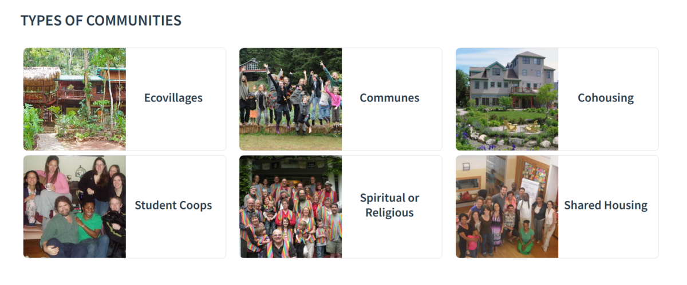See the following directory to explore. The directory looks like an excellent resource because communities can freely submit their entries which implies this should be a very complete resource.

Foundation for Intentional Communities: Directory
And this is their alpha list by country and state: Country / State List.
The search findings go to a clear summary page with the location, website link, and much more… all easily viewable for very efficient research:
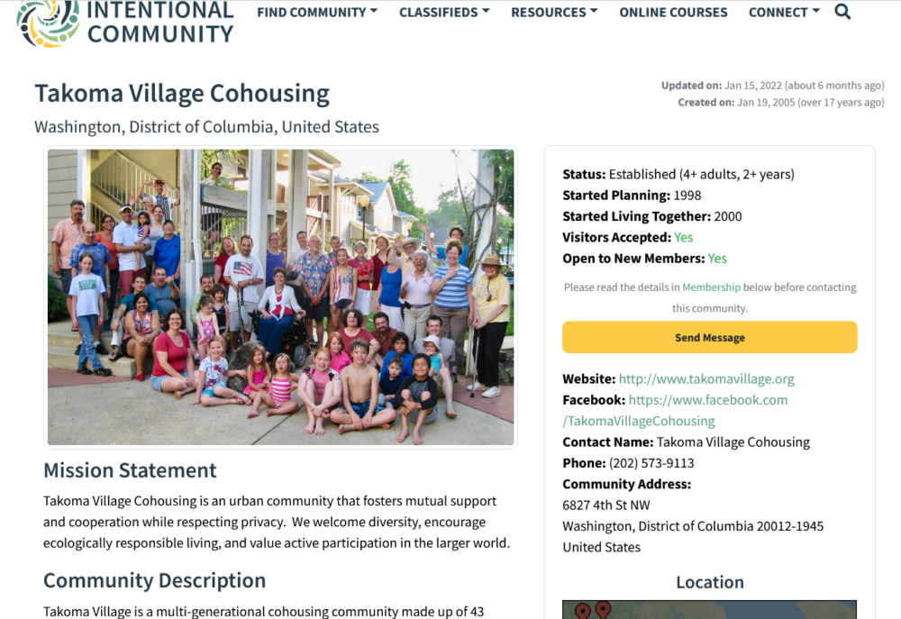
When we come across examples in research, we’ll list them here just to be sure they are recorded, but it’s likely the directory will have most of them and is an efficient way to research.
- Cohousing Association of the United States — link
- Dancing Rabbit Ecovillage — Northeast Missouri, US — link
- Earthaven Ecovillage — Near Asheville, North Carolina, US — link
- Eastlake Commons — Atlanta, Georgia, US — link
- Eco Truly Park — One hour from Cusco, Peru — link
- Ecovillage at Ithaca — Upstate New York, US — link
- Finca Bellavista Treehouse Community — Southern Costa Rica — link
- Lake Claire CoHousing — Atlanta, Georgia, US — link
- Milagro Cohousing — Near Tucson, Arizona US — link
- Polestar Gardens — Fort Collins, Colorado, US (previously in Hawaii) — based around the teachings of Paramhansa Yogananda link
- Serenbe — Atlanta, Georgia, US — link
- Synchronicity LA — Example of communal living based around art — link
- Takoma Village Cohousing — Washington DC, US — link
- Tamera — 2 to 3 hours form Lisbon, Portugual — link

What You Can Do
The only time you have control over is Now. A person can only feel or act or pay attention in the Now.
And with each Now moment, it’s possible to pause and take a conscious breath, observing what’s happening with a sense of curiosity. One moment at a time, you can peacefully choose to be in the power of you heart, to be free of subconscious programming, and to make your own choices.
- Begin quietly, with an inner focus. — What You Can Do and Where to Start: Proactive Empowerment & Human Resilience
- Get perspective. — The World as it Really Is. Making Sense of What Doesn’t Make Sense. The Great Aakening.
- Realize your power and take it back, step-by-step. — Become Aware of Where You’ve Given Your Power Away to Authorities & Systems That Shouldn’t Have It. Decide to Reclaim It.
- Go local. — The Failure of Systems. The Power of People. The Case for Going Local.

The End of a Cycle, and the Beginning of a New One
— The One We Choose to Create
Prophecies from the Mayan Calendar, Nostradamus and the Bible indicate that we are now living in ‘the end times’. Not necessarily the end of time, but certainly the end of time as we know it, the end of a cycle. Many of the ancient seers were able to see so far into the future and then no more. We are coming to a blank page, the beginning of a new chapter which we are yet to write. What this new chapter looks like is up to us.”
– A New Chapter by Dana Mrkich

