AN ESSAY TO SHARE

Become Aware of Where You’ve Given Your Power Away to Authorities & Systems That Shouldn’t Have It.
Choose to Reclaim It.
An essay you can share or copy from and make your own
by Shelly Thorn
v 2.3
Table of Contents
With every thought, feeling, word and action, 3
As a Youngster, Your Subconscious Mind Was Programmed 3
How the Subconscious Learns & Changes 5
How to Stop Running Subconscious Programs 5
How We Give Our Power Away 7
Outsourcing Power & Authority to “Society” 8
Who Are “The Authorities?” 8
We Have Reasonable Reasons 9
Misplaced Trust 11
View Succinct Examples & Verifiable Sources 11
Inspiring Models 13
Other Ways of Living 15
Foundation for Intentional Communities: Directory 15
What You Can Do 17
The Energy of Rebuilding Societies 18

With every thought, feeling, word and action,

you are choosing what you are empowering.

That is your free will and your ultimate power.

Have you thought about your power lately? Your innate power… your life force energy, your passion… your attention and focus… your physical abilities, intellectual approach and creativity… your money and influence… your care and support of others… your perspective and imagination… your potential. That’s a lot of power! How have you been using it?
Without a doubt, we all give a fair amount of our power away, both consciously and unconsciously. You might say we outsource it. Here we examine if some of that power is going to places that don’t deserve it.
If reading anything here causes your ego (a part of your mind) to feel a bit edgy or defensive, tell yourself that you don’t have to agree with anything or change in any way. This is just a discussion. And be assured that this isn’t information that will make you feel helpless and powerless. On the contrary, our investigation leads us to ways to get better results.

As a Youngster, Your Subconscious Mind Was Programmed
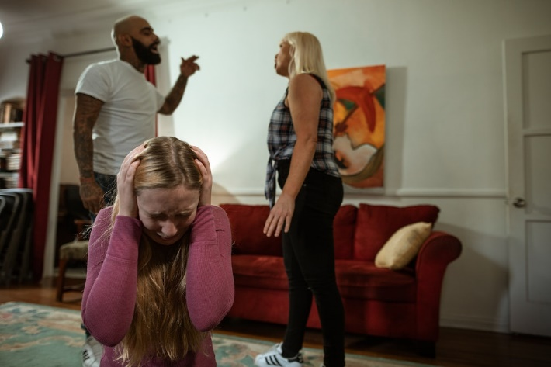
To be born onto planet Earth is to give away our inherent authority and power in big and small ways. How could we not? We were born into a baby’s body, helpless and reliant on caregivers for survival and connection. For many of us, our first two decades on the planet were spent under the auspices of parents or parental figures and other authorities: school teachers and administrators, sports coaches, arts teachers, police officers, doctors, employers and on and on.
It’s not as if, upon turning 18 or 21 or 30, that we suddenly stopped thinking and acting in all the ways we had been pressured or forced to by all those caregivers and authority figures. Sure, we might think we individuated in all the important ways, but looking closer, we find much we haven’t examined. Clues arise when we’re in new situations or under stress and find, for example, that we’re feeling anxiety that’s out of proportion, or we’re acting in ways that seem out of our control.
As a natural part of child development, we imbibed everything around us and filed it away in the subconscious. This is in part because our brains were in, basically, an altered state as youngsters. Dr. Bruce Lipton, stem cell biologist and author of The Biology of Belief, explains in the video below that in the first seven years of life, the brain operates at a lower frequency. During this time, the subconscious mind learns via a form of hypnosis, downloading what it observes.
As an adult, a person may be under the influence of the subconscious mind as much as 95% of the time.

How the Subconscious Learns & Changes
Lipton explains: Let’s say we read a book or watch a video and increase our knowledge. That is education of the conscious mind — but not the subconscious mind. Over time, we might “get really smart, but our life stays exactly the same.” Why? Because, as Lipton explains, the subconscious learns differently.
In the first seven years of life, the brain learns via a form of hypnosis, downloading what it observes. After young childhood, a key way the subconscious mind learns is via repetition.
After seven years of age, the subconscious mind learns via:
- Hypnosis
- Repetition and habituation
- Tremendous emotional shock
- Belief change modalities associated with energy psychology that offer a form of “super-learning” or the ability to change long-held patterns quickly. He explains that there are many of these belief-change modalities, one being PSYCH-K, a process of synchronizing the brain hemispheres.

How to Stop Running Subconscious Programs
Subconscious programs go into effect when the mind is engaged in thinking about the past or future. During these times of thinking, the subconscious programs switch on so that we can continue to function here and now.
This points to one of the reasons why mindfulness practices such as yoga and meditation are so effective at transforming lives. To be mindful is to be present and to observe rather than to automatically react, or to run “programs.” This means that mindfulness and meditation result in
- More time that subconscious programs are NOT running, and
- Increased awareness of previously-subconscious programming.
Thus, mindfulness beautifully subverts automatic take-over by the subconscious. And, thus, we can get a sense for how increased mindfulness leads to such powerful growth and transformation.
With the resulting increase in awareness and the ability to step back from the programming, we are more able to engage in repetition and instilling desirable habits as a powerful way of RE-programming the subconscious with CONSCIOUS intent.
11-min video - 4 Simple Strategies to Reprogram Your Mind | Dr. Bruce Lipton
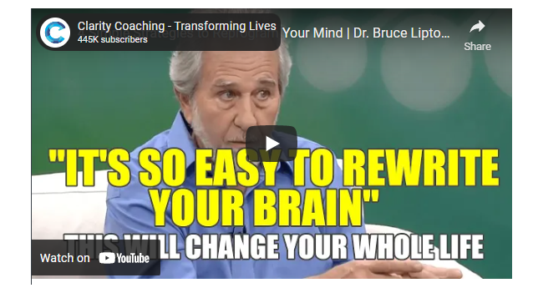
11-min video

How We Give Our Power Away
I may not know I’m giving away my power when:
- I make a decision to apply to a university or the military, to sign a rental lease, to get married or to purchase an expensive car or home… presuming either that I am lucky to have such opportunities, or that there are no possible alternatives for being happy or fulfilled.
- I don’t even think to research the information provided by a source that my family or social circle has dismissed.
I may not want to give my power away but feel I have no choice, when:
- I must listen to lectures that don’t have any real-world relevance, but I don’t think there are alternatives to being able to serve others, or because I feel I need the approval or the promise of future opportunity.
- To be in the military, I must give every ounce of freedom and power, but I don’t see another way to demonstrate my willingness to keep my community safe, or another way to get a job or education.
I may willingly give my power (of belief and action) to teachers, doctors, scientists, attorneys or other “experts” because:
- I see their title as a form of authority, thus stifling my own questioning, intuition, knowing and inner authority.
- I choose to believe their perspective in exchange for saving the time of doing the work to form an opinion on the subject at hand.
It takes a concerted effort to get a sense for just how far-reaching the impact of previous experiences with authority figures and social pressures have been on our lives. It requires becoming conscious of the unconscious programming which may just appear as our beliefs. When we see how they came to be and “unlearn” them, we create space to become more aware of, and aligned with, our inner knowing and uniqueness. Every one of us has given away our power to various degrees. So the question becomes, if we bring this subject to light, do we still wish to maintain the agreements we’ve been living by? During the year 2020, many people got a crash course in this idea when their lives were changed by outside forces, shining a spotlight on ways they had been living previously and providing them more time and space to question and make thoughtful decisions. For example, after being free of commuting, some people realized they no longer wished to spend hours each day in traffic. And some people found that spending more time in their living situation showed them it was actually unpleasant or unbearable (due to an unhealthy relationship or undesirable location, for example).

Outsourcing Power & Authority to “Society”
We’ve all been guilty of not speaking our truth to prevent discord, or acquiescing to the wishes of someone else despite a strong desire to act differently. This is often with a family member, a person in a social circle or a co-worker, but here we’ll focus specifically on the “experts,” “authorities” and systems that we’ve given our power to, and how that looks.

Who Are “The Authorities?”
Let’s examine how we typically think about “the authorities.” We’ve been trained to presume people with particular titles have authority over us. Teachers, police officers, judges, customs officials, lawmakers… and even surgeons, entertainers and corporate executives tend to get automatic authority status from many people.
In reality, the people who hold such titles are either public servants or those who hold opinions – not power over others.

The only power they have beyond holding opinions is that which we give them.
Consulting others for their opinion can, at times, be helpful. But the society we were born into was developed from stealing resources, wisdom and power (“colonialism”)… and it has been continued by people like us continuing to give away the power of decision-making.
Examples of the experts, authorities and systems we entrust to take action using our money, our overt approval, tacit acceptance, or acquiescence make up what is often called “society.”
- National government
- Local government
- Corporations
- Technology infrastructure providers
- Finance professionals
- Media
- Medical doctors
- University personnel
- Scientists
- Researchers
- Attorneys
- Teachers or “experts” with stamps of approval from any number of organizations
The people we are granting authority status to are employed within hierarchical control systems (which drastically minimize the power of the individual to act with humanity or integrity). The only people who can keep jobs in these systems are those who bow to the system itself, thus making the group’s priority the continuance of the system, as opposed to human values.
The way we give our power away is by outsourcing the authority to decide and act. In other words, we entrust a system or “authority” to do the right thing. Sometimes we entrust them to do something on our behalf. Sometimes we trust them to be a representative of a type of knowledge.

We Have Reasonable Reasons
We give our trust and faith to systems and experts for many perfectly reasonable reasons, of course. For example:
- We learned that this is how society works, and so we follow the program. My family and neighbors send their kids to the public schools and I don’t have enough money for private school, so I, of course, entrust my kids to the local school authorities. My spouse likes to have the TV on and is annoyed when I turn it off, so I allow the news and ads to be the background in my life.
- The authorities promise or agree to help us individually or to help the collective or the environment. My local government has been elected and paid to keep our community safe and prosperous and so if I see the police force treating someone inhumanely, I must presume that their actions are in alignment with the entrusted power.
- The people we’ve hired or entrusted have received a form of authorization that implies they have more knowledge, capability or experience than people who haven’t received the stamp of approval. I have the symptoms of a serious disease and so, no matter what the medical doctor tells me, I trust the advice based on his university credentials.
- We believe that if we do not support an existing system, we put vulnerable populations or the environment at risk. Of course I don’t love politics and government. But what else are we going to do?
In short, we believe that the capability, trustworthiness and reliability of the experts, authorities and systems that currently exist are better solutions than any others we know of or could devise, and so we support them. In other words, we believe that however poorly the current systems work, it’s better than their dissolution.
Check out this easy-to-read but powerful Medium article by Kristin Wilson, The Pandemic Proves That Society Was Wrong About How to Live Life. Here’s What to Do About It.
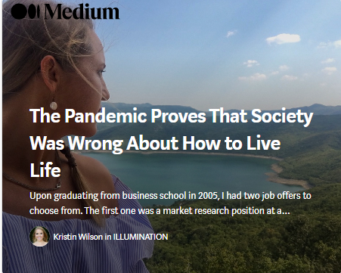
I’ve compiled a few outdated societal rules, norms, and assumptions worth abandoning from here on out… Lies society has told you about Your Career… How Business Works… Government & Institutions… Your Health… The World… How to Live Your Life…
Did you know that there are music producers who don’t know anything about music theory? Or that you don’t have to go to film school to become a filmmaker? Or that you could make six-figures freelancing online from Bali? What if flouting the rules wasn’t a recipe for disaster, but rather a road map for finding happiness and fulfillment in life?
– Kristin Wilson

Misplaced Trust
Many good people have done many good things. But systems (especially those under hierarchical control) have proven to be vulnerable to corruption, and are now manipulated by a few massive corporations. Mainstream media is a perfect example of the process of a system moving from journalism to narrative control.
When we peer beneath the surface of media and corporate narratives, there is endless proof that the largest and most mainstream systems today are not, in fact, trustworthy:

View Succinct Examples & Verifiable Sources
- The Need to Reclaim Our Power: How Corporations Betray Humanity
- The Need to Reclaim Our Power: How Governments Betray Humanity
- The Need to Reclaim Our Power: How Modern Medicine and the FDA Betray Humanity
- The Need to Reclaim Our Power: How Researchers (in the Name of “Science”) Betray Humanity
- The Need to Reclaim Our Power: How the Education System Betrays Humanity
- The Need to Reclaim Our Power: How the Financial System Betrays Humanity
For example, in How Corporations Betray Humanity, you’ll see such examples as:
- Pharma Lying & Manipulation — Seven research trials; six showed the drug doesn’t work. The manufacturer published only the one that had a positive result.
- Pharma’s Corrupt Practices Specified in Exquisite Detail — They give lavish gifts to physicians, promote new “diseases,” set up phony “patient advocacy organizations,” “educate” doctors about drug’s unapproved uses, bury studies they don’t want seen, and more.
- Nestlé, Coca Cola, Danone, Unilever — Big food corporations control markets while farmers and consumers are held accountable for the devastation.
- Pharmaceutical Corporations Intensely Target Med Students — Recognizing the formative nature of the clinical years of medical education, pharmaceutical companies seek to influence medical students years before they are ready to independently practice medicine.
- Big Pharma Are Big Lobbyists — Pharmaceutical corporations are among the largest lobby groups in Washington DC. How is government lobbying by corporations different from bribery and corruption?
- Pharma Targets Election Candidates — Pharmaceutical control tactics include lying about candidates up for election.
- Pfizer Has Been Assessed Billions In Criminal Convictions — If the penalty for criminality doesn’t change the criminal behavior, is the system working?
- Insulin Founders Gave Away Patent for $1 Because “Insulin Belongs to the World”— Pharmaceutical corporations monopolized the distribution of insulin, charging diabetics $750/month. See also: The High Price of Insulin Is Literally Killing People.

Big Food Corporations Control Markets While Farmers & Consumers Are Held Accountable for the Devastation
Large-scale food and beverage companies… play an outsized role in driving disparities in human health and environmental sustainability. Food processing companies currently make one-fourth of every dollar spent on groceries in the U.S., with just a handful of companies controlling as much as 98.4% of the market share in some categories of prepared foods. By comparison, the country’s more than 2.5 million farmworkers, the majority of which are undocumented and unprotected by fair wage laws, get just eight cents for every dollar spent on groceries.
Food processing companies like Nestlé (Switzerland), Coca Cola (U.S.), Danone (France), and Unilever (United Kingdom/Netherlands) are bottlenecks in the global food system, exerting undue influence over both what and how much is produced by farmers upstream as well as what and how much is eaten by consumers downstream… Despite this concentration of power and wealth, international agendas for public health and sustainable food production often call for reform not by the most powerful food companies but, instead, by farmers and consumers.
– Stop Blaming Consumers — It’s Time to Hold Big Food Accountable
See Also: The Failure of Systems. The Power of People. The Case for Going Local.

Inspiring Models
No matter our differences, we can each observe our own behavior regarding authority and power and consider how it’s been working. Has what we’ve been doing gotten the results we wanted?
The systems that have betrayed humanity are the same ones that have the power and influence to inundate us with messages that they are the only way our world can work. So is it any surprise that many people find it hard to believe that it’s possible to reject these systems and try new things? Humanity has been force-fed the false idea that corporate growth helps people and that governments as they exist today are capable of leading humanity. The strong implication is that a breakdown of “society” will be the end of everything good and will make survival impossible.
And yet there are so many examples of people making independent choices to create new ways of living with their family and neighbors. You might find some of these thought leaders and activists inspiring in their approach.
- Vandana Shiva — Has supported Indian farmers in achieving multiple successes with knowledge, community and teamwork.
- Rosa Parks — “In 1955, Parks rejected a bus driver’s order to leave a row of four seats in the ‘colored’ section once the white section had filled up and move to the back of the bus. Her defiance sparked a successful boycott of buses in Montgomery a few days later. Residents refused to board the city’s buses. Instead they carpooled, rode in Black-owned cabs, or walked, some as far as 20 miles. The boycott dealt a severe blow to the bus company’s profits as dozens of public buses stood idle for months. The boycott was led by a newcomer to Montgomery named Martin Luther King, Jr.”
- Gandhi — Gandhi’s use of the spinning wheel was, in part, a way to demonstrate economic freedom for his people to regain independence from British rule. “Gandhi’s use of the spinning wheel was one of the most significant unifying elements of the nationalist movement in India. Spinning was seen as an economic and political activity that could bring together the diverse population of South Asia, and allow the formerly elite nationalist movement to connect to the broader Indian population…. It… had the potential to overcome labour, gender, and religious divisions and thereby produce an accessible and effective symbol for the Gandhian anti-colonial movement.”
- Cesar Chavez — “A first-generation American, he was born in 1927 near his family’s small homestead outside Yuma, Arizona. At age 11, his family lost their farm during the Great Depression and became migrant farm workers. Cesar finished his formal education after the eighth grade and worked the fields full-time to help support his family… Cesar’s dream was to organize a union that would protect and serve the farm workers whose poverty and powerlessness he had shared. He knew the history of farm worker organizing was one sad story after another of broken unions and strikes crushed by violence. He knew that for 100 years many others with much better educations and more resources than he possessed had tried, and failed, to organize farm workers. He knew the experts said organizing farm workers was impossible.”
- The Grandmother Who Resisted — “Standing Rock Grandmother Regina Brave has been compared to Rosa Parks when it comes to… the Water Protectors praying and holding space to block the pipeline in North Dakota.” Brave resisted arrest as she believed it within her rights to peacefully pray in support of the Standing Rock tribe’s efforts to resist the oil pipeline that threatens their fresh water. (The efforts included years of extensive efforts to go through the political and legal systems.) A nearby richer city had successfully refused to accept the pipeline but the Indian reservation’s sovereignty was not similarly respected by the corporate and government powers.
- Tiny House Network — Connections and support for sustainable living.
- Intentional Communities, Ecovillages & Cohousing — Information and resources.

Other Ways of Living
Many people have created ways of working together to grow food and build networks of support. The following image clip shows types of communities featured in an Intentional Communities directory.
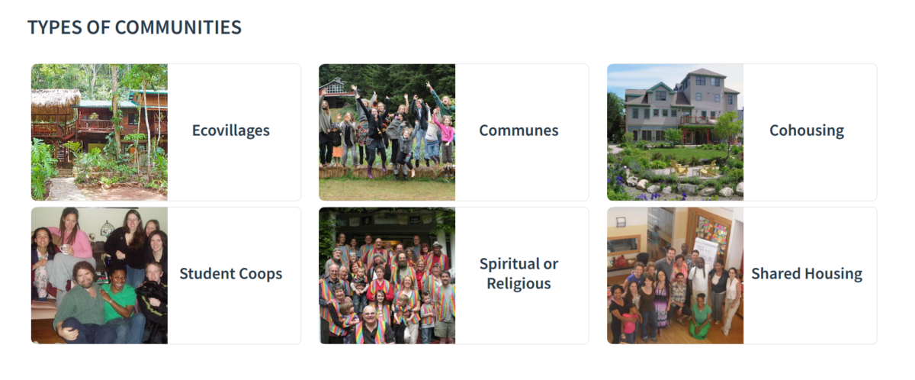See the following directory to explore. The directory looks like an excellent resource because communities can freely submit their entries which implies this should be a very complete resource.

Foundation for Intentional Communities: Directory
And this is their alpha list by country and state: Country / State List.
The search findings go to a clear summary page with the location, website link, and much more… all easily viewable for very efficient research:
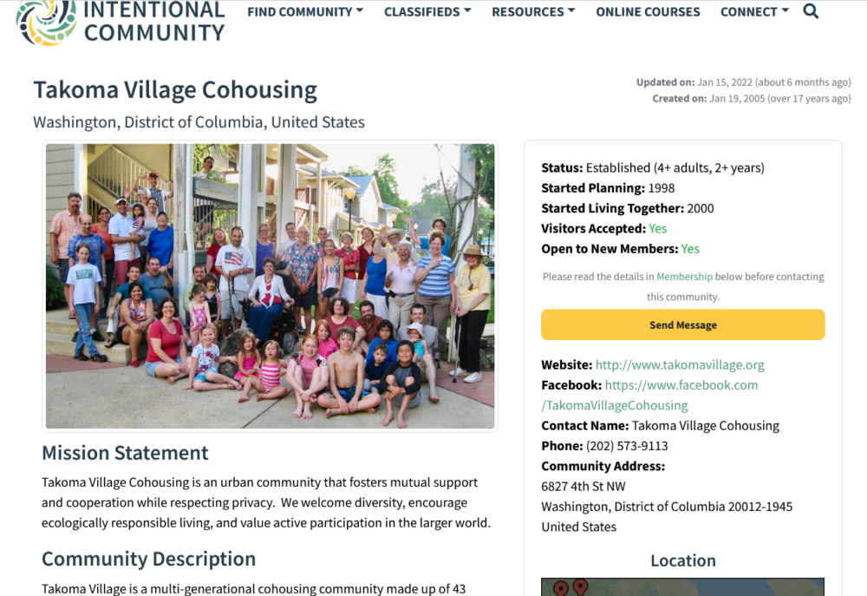
When we come across examples in research, we’ll list them here just to be sure they are recorded, but it’s likely the directory will have most of them and is an efficient way to research.
- Cohousing Association of the United States — link
- Dancing Rabbit Ecovillage — Northeast Missouri, US — link
- Earthaven Ecovillage — Near Asheville, North Carolina, US — link
- Eastlake Commons — Atlanta, Georgia, US — link
- Eco Truly Park — One hour from Cusco, Peru — link
- Ecovillage at Ithaca — Upstate New York, US — link
- Finca Bellavista Treehouse Community — Southern Costa Rica — link
- Lake Claire CoHousing — Atlanta, Georgia, US — link
- Milagro Cohousing — Near Tucson, Arizona US — link
- Polestar Gardens — Fort Collins, Colorado, US (previously in Hawaii) — based around the teachings of Paramhansa Yogananda link
- Serenbe — Atlanta, Georgia, US — link
- Synchronicity LA — Example of communal living based around art — link
- Takoma Village Cohousing — Washington DC, US — link
- Tamera — 2 to 3 hours form Lisbon, Portugual — link

What You Can Do
The only time you have control over is Now. A person can only act in the Now. And with each Now moment, it’s possible to pause and take a conscious breath, observing what’s happening with a sense of curiosity.
One moment at a time, you can peacefully choose to be in the power of you heart, to be free of subconscious programming, and to make your own choices.
- Begin quietly, with an inner focus. — What You Can Do and Where to Start: Proactive Empowerment & Human Resilience
- Get perspective. — The World as it Really Is. Making Sense of What Doesn’t Make Sense. The Great Aakening.
- Realize your power and take it back, step-by-step. — Become Aware of Where You’ve Given Your Power Away to Authorities & Systems That Shouldn’t Have It. Decide to Reclaim It.
- Go local. — The Failure of Systems. The Power of People. The Case for Going Local.

The End of a Cycle, and the Beginning of a New One
— The One We Choose to Create
Prophecies from the Mayan Calendar, Nostradamus and the Bible indicate that we are now living in ‘the end times’. Not necessarily the end of time, but certainly the end of time as we know it, the end of a cycle. Many of the ancient seers were able to see so far into the future and then no more. We are coming to a blank page, the beginning of a new chapter which we are yet to write. What this new chapter looks like is up to us.”
– A New Chapter by Dana Mrkich

The Energy of Rebuilding Societies
It is said that we have entered the “Age of Aquarius.” Whether or not you’re familiar with astrology, it can be enlightening to simply note that the 12 astrological signs each represent a type of observable energy. The energy is something real that you are familiar with and have experienced or observed. The sign (e.g. Aries, Cancer, Sagittarius) is just a name given to that real experience or how energy can manifest.
The energy of each sign has a Light and Shadow aspect – meaning ways that the energy is positively expressed or negatively expressed, also called the higher octave and the lower octave.

How Aquarius Energies Can Inspire Us Now
Aquarius helps us form a society [and] it also helps us break it down and rebuild. This energy brings out our vision of who we are, who we are within a collective, and what change needs to happen so everyone in the collective feels society is serving them. Aquarius reminds us that we are all connected and that we all breathe the same air. We are all part of the same energetic web, and we are all influenced by the collective consciousness. We also all have a responsibility to contribute to humanity and help evolve it by finding out who we are and speaking our truth…
Work with these energies to break free of any societal programming that demands you fit into the status quo. Instead, give yourself the freedom to stand in your truth and share it. Know that not everyone will agree with you, and that it’s OK. What’s important is that you remain confident in yourself and aligned with your integrity. When you show up in the world with the energy of confidence and integrity, people listen, society listens, and you end up changing the world.
… The highest frequency of Aquarius sees everyone as equal, no better or worse than their neighbor. Furthermore, everyone is entitled to live their life as they choose. Individual freedom is at the center of this frequency. Like Leo, Aquarius’s energy asks that we show up as ourselves in every situation. Aquarius goes one step further and asks us to accept others just as they are because, in reality, we are all the same, and we are all one. The more we accept the collective, the more we can accept ourselves and vice versa. The higher vibration of Aquarius gives way for people to be themselves, without judgment and without feeling like they need to fit into some box designed by someone else. It is true freedom based on unconditional love for all of humankind…
Aquarius also has a lower side to its energy. This shadow, or extreme, side forgets about the individual and their unique needs. When we align with this frequency, we forget to take personal responsibility for the problems around us. We blame the larger organizations that govern and spin tales of what should be done instead of realizing we contribute to the greater whole… Blaming is a disempowering energy. When we blame, we forget that we are just as powerful as and equal to the people making the rules that ultimately dictate our personal freedom. We each have a responsibility to contribute our uniqueness, voice, and greatness to the world. If we all do this, we change the frequency of the planet. Look to the houses in your natal chart to find areas of your life governed by the energy of Aquarius. Do you notice any of these lower or higher vibrations in these places? How can you shift toward a higher vibration of love and acceptance for all, including yourself?
- Jill Wintersteen

